AI ASSISTED CODING

# ASSIGNMENT:3.1

**Name:MD ZIAUDDIN**

**Rollno:2403A51271**

TASK1:

Prompt:

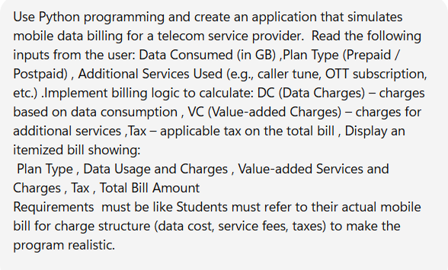

Code:

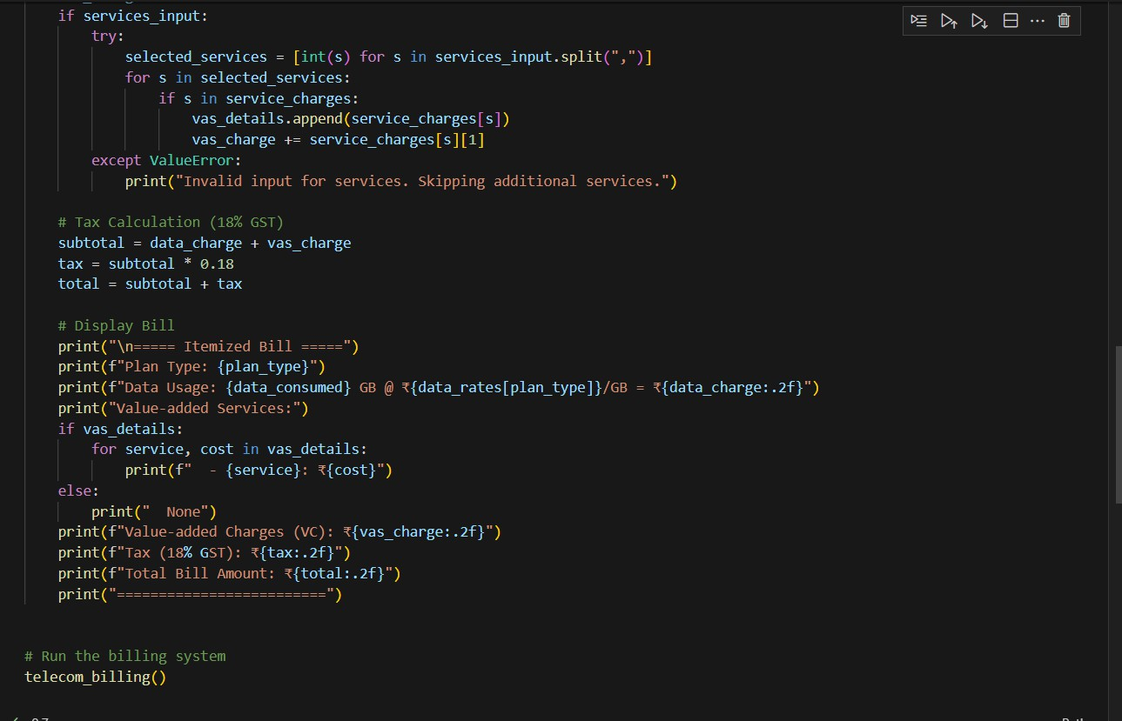

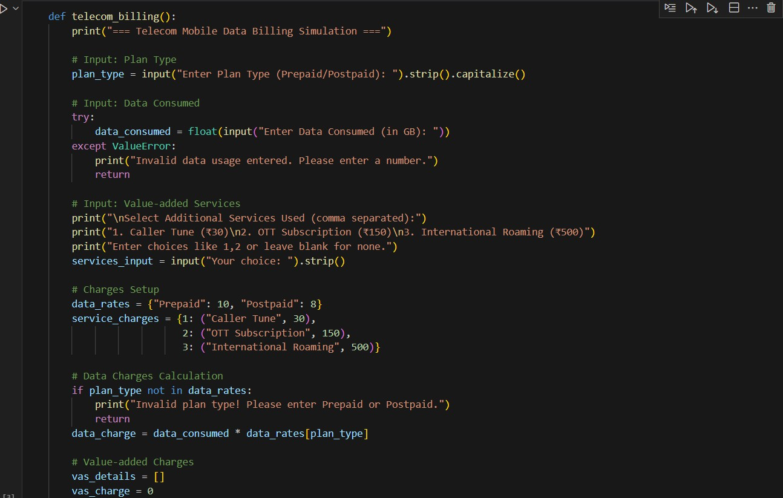

Output:

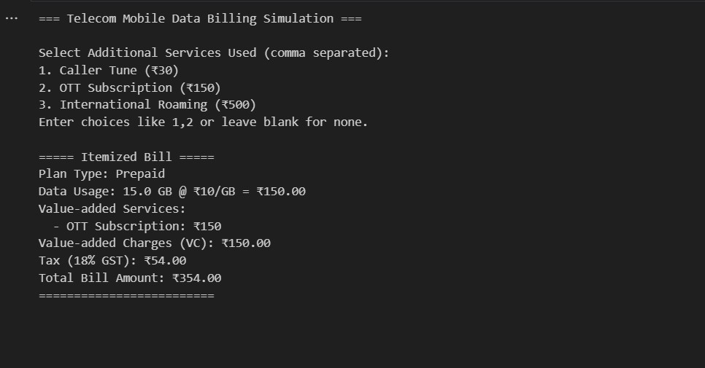

Task2:

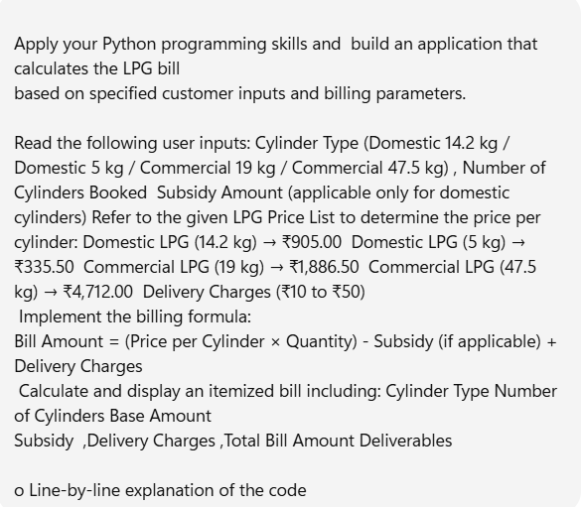

Code :

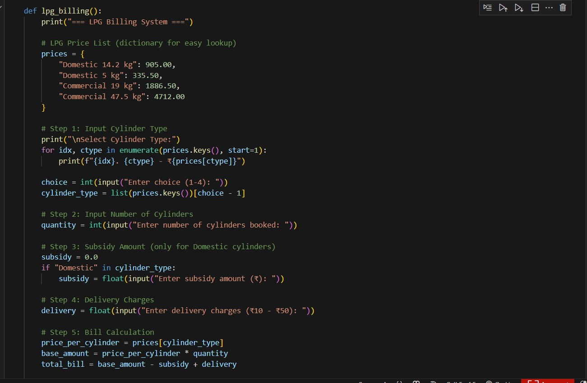

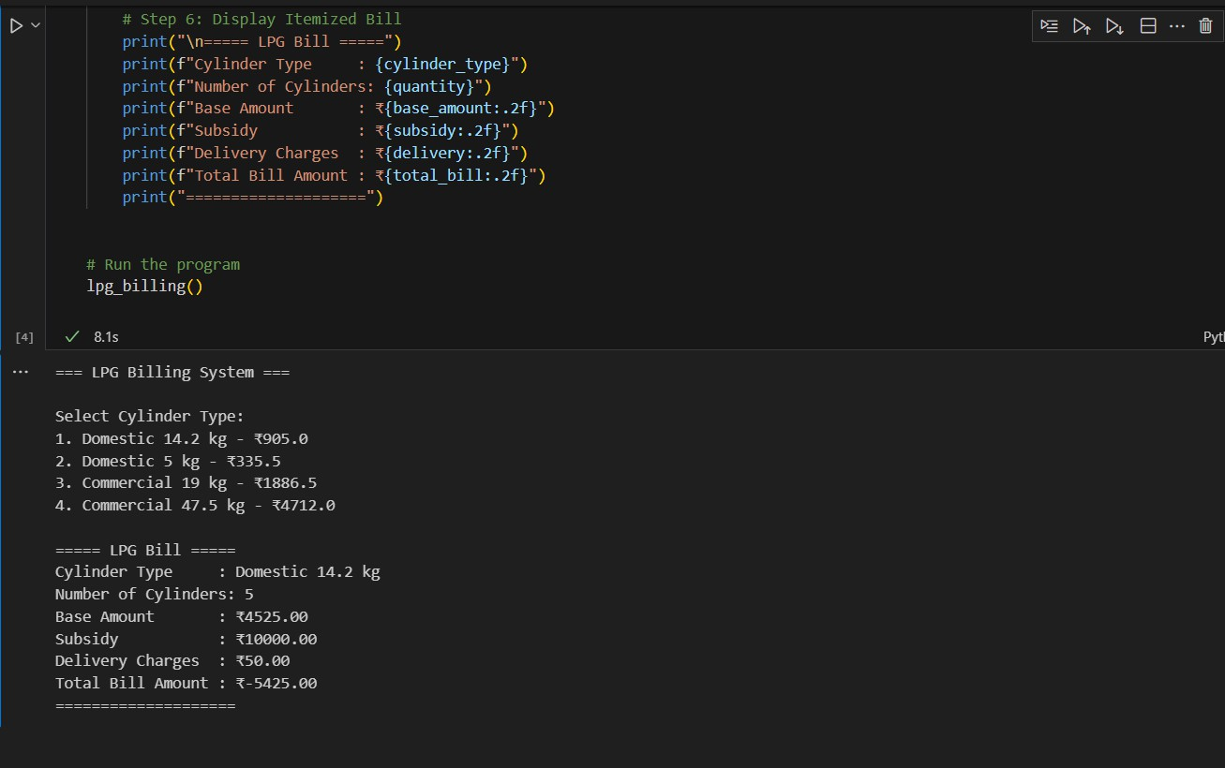

Explanation:

# ⬛ Line-by-Line Explanation

1. **Define function**
2. def lpg_billing():

We define a function lpg_billing() that contains the whole logic.

# Print header

1. print("=== LPG Billing System ===") Displays a title for the billing system.

# Price list dictionary

1. prices = {
2. "Domestic 14.2 kg": 905.00,
3. "Domestic 5 kg": 335.50,
4. "Commercial 19 kg": 1886.50,
5. "Commercial 47.5 kg": 4712.00

11. }

Stores price per cylinder for each type in a dictionary for quick lookup.

# Show cylinder type menu

1. for idx, ctype in enumerate(prices.keys(), start=1):
2. print(f"{idx}. {ctype} - ₹{prices[ctype]}") Prints options like:
3. Domestic 14.2 kg - ₹905.0
4. Domestic 5 kg - ₹335.5

...

# Take user choice

1. choice = int(input("Enter choice (1-4): "))
2. cylinder_type = list(prices.keys())[choice - 1]

Converts user input to index, then fetches cylinder type from dictionary.

# Take number of cylinders

1. quantity = int(input("Enter number of cylinders booked: ")) User enters how many cylinders they want.

# Subsidy only for domestic cylinders

1. subsidy = 0.0
2. if "Domestic" in cylinder_type:
3. subsidy = float(input("Enter subsidy amount (₹): ")) Checks if cylinder type contains "Domestic". If yes, ask subsidy.

# Delivery charges

1. delivery = float(input("Enter delivery charges (₹10 - ₹50): "))

# Bill calculation

1. price_per_cylinder = prices[cylinder_type]
2. base_amount = price_per_cylinder * quantity
3. total_bill = base_amount - subsidy + delivery Formula:

Bill Amount=(Price per Cylinder×Quantity)−Subsidy+Delivery Charges\text{Bill Amount} = (\text{Price per Cylinder} \times \text{Quantity}) - \text{Subsidy} + \text{Delivery

Charges}Bill Amount=(Price per Cylinder×Quantity)−Subsidy+Delivery Charges

# Display bill

1. print("\n===== LPG Bill =====")
2. print(f"Cylinder Type : {cylinder_type}")
3. print(f"Number of Cylinders: {quantity}")
4. print(f"Base Amount : ₹{base_amount:.2f}")
5. print(f"Subsidy : ₹{subsidy:.2f}")
6. print(f"Delivery Charges : ₹{delivery:.2f}")
7. print(f"Total Bill Amount : ₹{total_bill:.2f}")
8. print("====================")

Shows a clean, itemized bill.

⬛ **Sample Run**

=== LPG Billing System ===

Select Cylinder Type:

1. Domestic 14.2 kg - ₹905.0
2. Domestic 5 kg - ₹335.5
3. Commercial 19 kg - ₹1886.5
4. Commercial 47.5 kg - ₹4712.0

Enter choice (1-4): 1

Enter number of cylinders booked: 2 Enter subsidy amount (₹): 100

Enter delivery charges (₹10 - ₹50): 25

===== LPG Bill =====

Cylinder Type : Domestic 14.2 kg Number of Cylinders: 2

Base Amount : ₹1810.00 Subsidy : ₹100.00

Delivery Charges : ₹25.00 Total Bill Amount : ₹1735.00

====================